

2025 ASABE Student Robotics Challenge Robotics Design Report

Team Name: Machine Family

Division: Beginner

Affiliation: Zhejiang University

Team Members: Zaiyang Song, Yangyi Gu, Tianle He,

Zixuan Huang, Qingyi Ma

Team Advisor: Yonghua Yu, Zunzhong Ye, Yibin Ying, Huanyu Jiang

Contact: guyy9341@gmail.com

Catalog

1 Team Introduction 2
Table 1-1 Personal Introductions 2
2 Current status and applications in agriculture 2
2.1 Egg industry scale 2
2.2 Automated egg collection and sorting robot 4
2.3 Agricultural and Operational Benefits 5
3 Definition of Design Objectives and Criteria 5
4 Approach 6
4.1 Navigation Module 7
4.2 Collection & Sorting Module 8
4.3 Feedback Display Module 9
5 Parts List and Table 10
Table 5-1 Parts List and Cost 10
6 Hardware Description 12
6.1 The Manipulation Module 12
6.1.1 The Picking Mechanism 13
6.1.2 The Storage Mechanism 14
6.1.3 The Discharge Mechanism 14
6.2 The Mobility Module 15
6.3 The Control Module 16
6.3.1Arduino Mega 2560 Pro 16
6.3.2 Laser Based Photoelectric Sensor 17
6.3.3 Thin Film Pressure Sensor 18
6.3.4 Camera 19
6.3.5 Printed Circuit Board 19
7 Software Overview 20
7.1 Overall Software Workflow 20
7.2 Visual Navigation Module 22
7.3 Egg Detection and Collection Module 23
8 Achievement of the Objectives 25
9 References 25

1 Team Introduction
In preparation for the 2025 ASABE race we've got five sophomores to run in the race. In order to build an automatic robot that aligns with the rules, each member demonstrated their own specialty and strengths during the preparation process. Our personal introductions are as follows:

Table 1-1 Personal Introductions
Name | Major | Assigned Tasks | Identity
Zaiyang Song | Biosystems Engineering | Mechanical Design and  Modelling | Undergraduate Sophomore
Yangyi Gu | Biosystems Engineering | Mechanical Assembly | Undergraduate Sophomore
Tianle He | Biosystems Engineering | Machine Vision and Programming | Undergraduate Sophomore
Zixuan Huang | Biosystems Engineering | Circuit Design and Debugging | Undergraduate Sophomore
Qingyi Ma | Biosystems Engineering | Embedded System Design  Programming | Undergraduate Sophomore

2 Current status and applications in agriculture

2.1 Egg industry scale
In many poultry farming systems, egg collection remains a labor-intensive task, especially in floor-based and non-cage systems. In such environments, eggs are scattered on the ground and must be picked up manually. This task typically involves prolonged physical labor and repeated bending. These factors lead to increased labor costs, health and safety risks for workers, and a higher likelihood of product damage.
According to the USDA Economic Research Service (2020), labor represents approximately 30–35% of operational variable costs in small- to mid-scale poultry farms in the United States, with egg handling comprising a substantial portion. In countries with lower degrees of agricultural mechanization, the problem is more pronounced. Persistent labor shortages and rising wages further exacerbate the challenge of efficient egg collection in developing regions.
Figure 2-1 The Labour Gap Widens for the ‘ Poultry and Egg ’ Industry
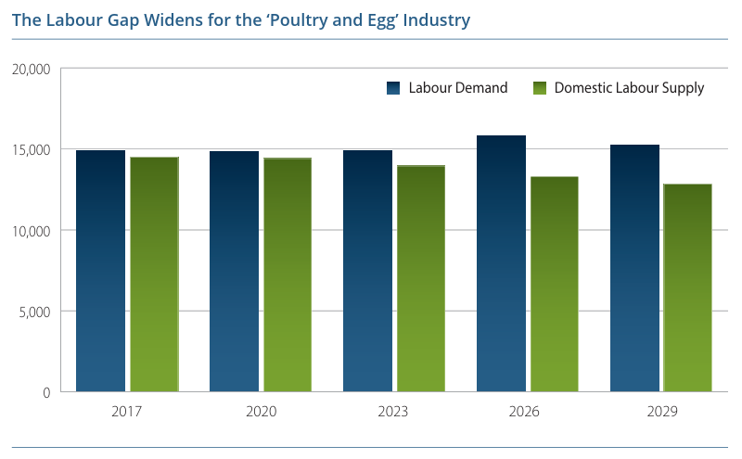
Figure 2-2 Productivity, Output, and Labour Demand Trends
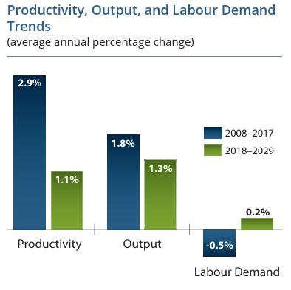

2.2 Automated egg collection and sorting robot
In order to meet growing demand, we want to develop an autonomous egg collection and sorting robot suitable for flat poultry farming environments. The robot will primarily be capable of automating the following tasks:
- Path navigation based on computer vision algorithms using an OpenMV Cam with OpenCV.
- Egg acquisition using a servo-actuated thin plastic flap that sweeps eggs into a 3D-printed collection cage.
- Synchronous weight-based classification utilizing an RP-S40-LT thin-film pressure sensor embedded beneath the sweeping mechanism.
- Targeted deposition of classified eggs into separate containers, with shock-absorbing sponge or fabric buffers depending on quality.
This integrated approach enables a closed-loop process from perception to action. The system is optimized for indoor operation, with a compact chassis, modular layout, and use of low-cost components, such as 42-stepper motors, acrylic structural materials, and standard servo actuators.
Figure 2-3 Floor-rearing Farm
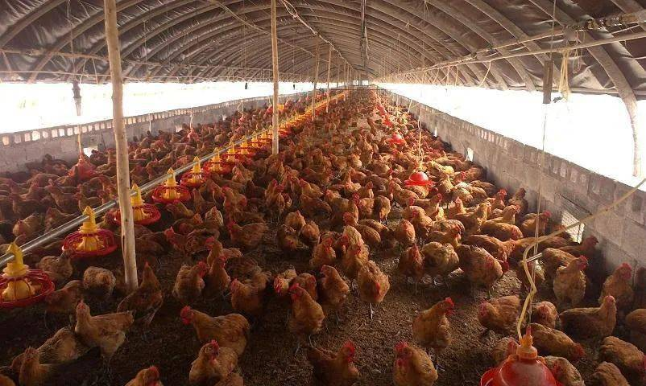

2.3 Agricultural and Operational Benefits
Our robots are designed to improve efficiency and productivity, with the primary goal of reducing labor costs and physical strain on workers. Here are some of the advantages of automated and mechanized egg collection and sorting:
- Improved egg integrity: Through low-force sweeping and non-intrusive handling, the system minimizes breakage. Real-time weight detection allows immediate separation of non-conforming eggs.
- Consistency and traceability: The system applies uniform criteria for sorting, eliminating the subjectivity inherent in manual inspection.
- Suitability for small to medium-scale operations: Unlike large conveyor-based systems, the robot operates independently without fixed infrastructure, supporting deployment in flexible environments.
- Cost efficiency and scalability: The robot uses readily available hardware and open-source control platforms (Arduino Mega 2560), supporting low-cost assembly and future adaptation.
In summary, the developed robotic system meets a recognized need in the poultry production sector by providing an extensible, efficient, and practical solution to automate egg collection and classification. Its design prioritizes structural simplicity, sensor integration, and adaptability, making it suitable for both experimental deployment and eventual field application.

3 Definition of Design Objectives and Criteria
According to the rules, the robots to be designed for this competition should have the ability to recognize the large eggs and medium bad eggs. In order to achieve the goal efficiently, we have divided the project into some detailed and specific sub-points, including:
∎ Autonomous Navigation:
The robot must autonomously follow floor lines or marked paths using its vision system. The OpenMV camera with OpenCV processes images to steer the robot without external guidance.
∎ Egg Collection Mechanism:
The robot should rapidly collect eggs within its reach. A servo-driven thin plate sweeps nearby eggs into a central collection cage. This mechanism must operate in one step, capturing eggs efficiently without repeated attempts.
∎ Classification and Feedback:
Each egg is weighed by an onboard pressure sensor. The system classifies eggs as good or bad based on a calibrated weight threshold. Clear LED indicators (green for good, red for bad) immediately show the result. High classification accuracy (target >95%) is required.
∎ Sorting into Bins:
The manipulator arm must deposit each egg into the correct bin. Good eggs are gently placed into the sponge-lined bin, while bad eggs are directed onto the cloth-covered inclined ramp. Drop distances are minimized to avoid jarring impacts.
∎ Protection of Eggs:
Design criteria demand minimal breakage. The good-egg bin’s sponge cushion absorbs shocks, and the bad-egg bin’s cloth ramp safely contains defective eggs.
∎ Performance and Reliability:
The system should handle a high throughput (dozens of eggs per minute) with a very low breakage rate. It must operate continuously throughout the task without failure. Durability in dusty, variable farm conditions is essential.

4 Approach
The robotic system adopts a modular design framework, consisting of three core subsystems: Navigation Module, Collection & Sorting Module, and Feedback Display Module. Each subsystem is independently designed to execute its specific functional role, while all modules are centrally coordinated through an Arduino Mega 2560 controller. The modular structure ensures high maintainability, allows for parallel development, and facilitates rapid troubleshooting and system optimization.
  - Navigation Module
The navigation module is responsible for enabling autonomous movement by employing a vision-based line-following strategy. An OpenMV Cam integrated with OpenCV performs real-time image acquisition and processing. A white spray paint laid on the floor serves as the visual guide. The camera isolates the region of interest, applies binary thresholding and morphological operations, and extracts the contour of the black line. The computed center offset (dx, dy) between the path and the image center is transmitted via UART to the Arduino Mega 2560.
Figure 4-1 Navigation Data Flow
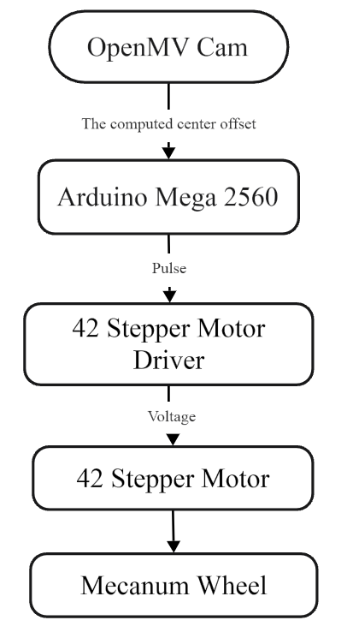
The Arduino interprets this feedback to generate directional adjustments. It directly controls four 60 mm Mecanum wheels, each driven by a 42-stepper motor through A4988 drivers. The navigation is purely open-loop, with no reliance on wheel encoders or IMUs, making the design cost-effective and structurally simple. Despite this simplicity, the system achieves sufficient accuracy and responsiveness for indoor environments. Visual loss detection is also implemented to halt operation if the guide line is no longer visible.
Figure 4-2 58 mm Mecanum wheels Figure 4-3 42-stepper motor
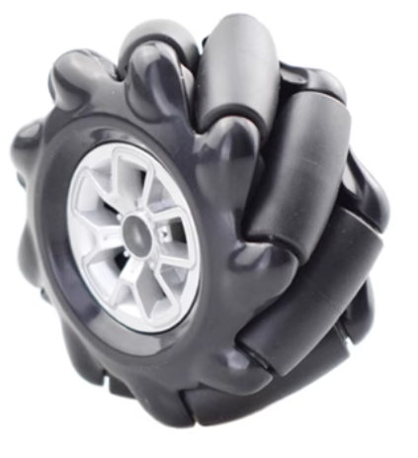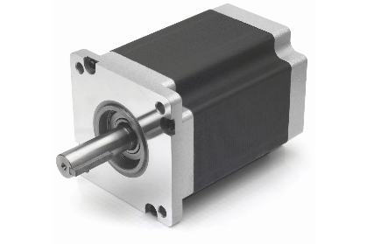
  - Collection & Sorting Module
The collection and sorting module is an integrated subsystem that performs egg acquisition, real-time weight measurement, and classification, all within a single continuous action cycle. This functional integration is achieved through a 3D-printed egg collection cage, which serves as the end-effector of a lightweight robotic arm.
At the core of this design is a thin plastic flap driven by a micro servo motor. When aligned with a detected egg, the Arduino triggers the servo to sweep the flap forward, gently pushing the egg into the cage. Embedded directly beneath the flap is an RP-S40-LT thin-film pressure sensor, which immediately captures the egg’s weight as it enters. The Arduino processes this weight data in real time and classifies the egg as either “good” or “bad” based on a predefined threshold.
Following classification, the robotic arm deposits the egg into one of two 3D-printed receptacles:
•● A sponge-lined box for solid eggs to absorb impact and prevent cracks.
•● A fabric-covered inclined chute for bad eggs, which safely guides them away while minimizing breakage.
This design features a tight integration of mechanical actuation and sensor-based classification, representing an original solution tailored for handling fragile materials. It eliminates the need for complex gripping or weighing stations and enables fast, synchronized operation with minimal hardware complexity.
Figure 4-4 Sponge Material Figure 4-5 Fabric Material
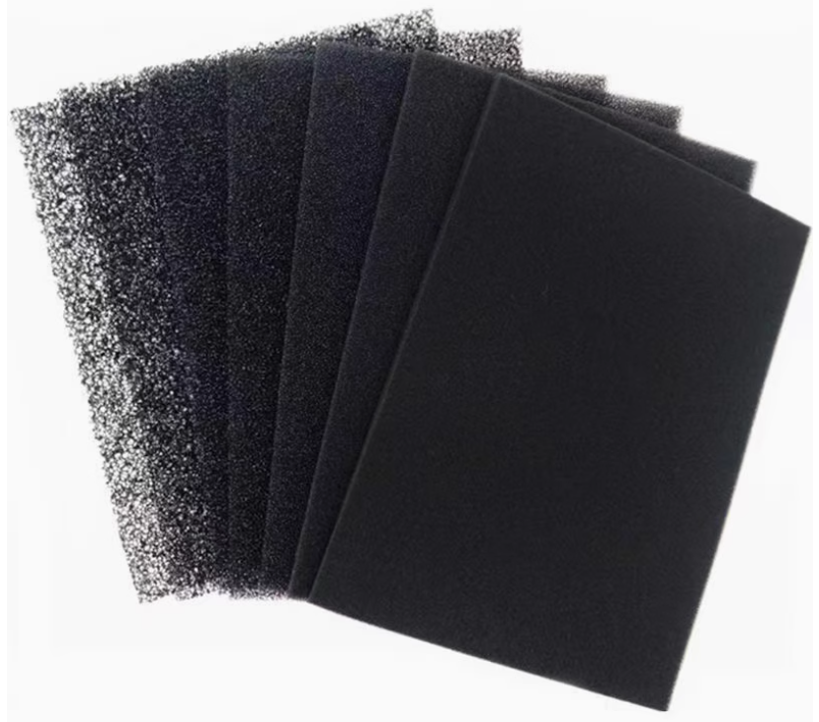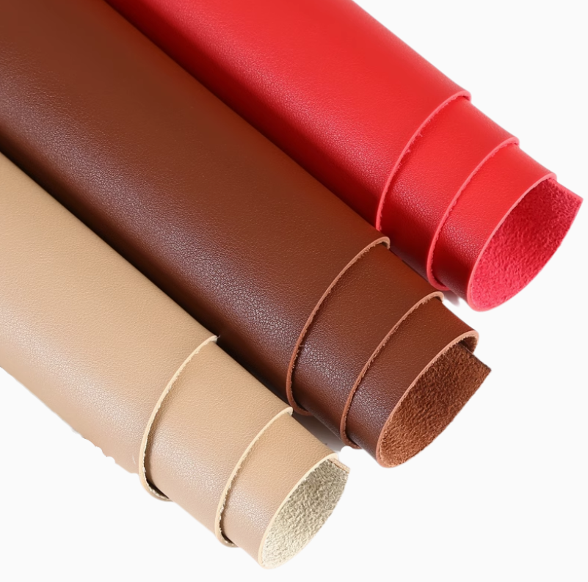
  - Feedback Display Module
The feedback display module serves to provide real-time visual status indicators and enhance operator interaction. The system includes two onboard LEDs:
● Green LED: Indicates a good egg has been detected and sorted.
● Red LED: Indicates a bad or abnormal egg.
These indicators are activated immediately after the pressure sensor outputs its classification result. This lightweight feedback mechanism is particularly useful during live demonstration, testing, and debugging.
Optionally, the Arduino Mega 2560 can output performance statistics, including total eggs processed, classification counts, and error flags, to an external serial monitor or small OLED display. The feedback display module is designed as a passive listener on the control bus, ensuring it does not interfere with core real-time operations such as motor actuation or sensor polling.
Figure 4-6 LED Light
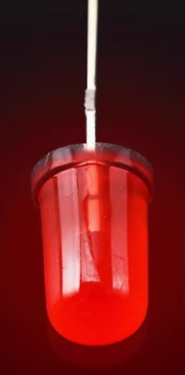

5 Parts List and Table
The total cost of our robot was $273.39. We used Arduino and OpenMV as processor device, which cost $53.60(According to the exchange rate on June 30.).

Table 5-1 Parts List and Cost
No. | Item | Type.(Spec) | Qty | Unit Price  (RMB) | Total Price  (RMB)
1 | Arduino | Mega2560 Pro | 1 | 64.90 | 64.90
2 | 42 Stepper Motor | 42BYGH47 | 4 | 39.90 | 159.60
3 | Stepper Motor Frame | 42 Stepper Motor | 4 | 4.90 | 19.60
4 | 42 Stepper Motor  Driver | / | 4 | 64.90 | 259.60
5 | Servo | Dual Axis 270°20kg | 2 | 70.00 | 140.00
 |  | 20kg | 4 | 36.00 | 144.00
 |  | 35kg | 1 | 118.00 | 118.00
6 | Printed Circuit Board | Customized | 1 | 69.90 | 69.90
7 | Acrylic Plate | 5 mm/Customized | / | / | 120.00
8 | Copper Pillar | 40mm | / | / | 10.00
9 | Screw | M3*8/M3*10 | / | / | 10.00
10 | Nut | M3 | / | / | 4.00
11 | 4S Battery | 4 S 16.8 V | 1 | 58.80 | 58.80
12 | 3D Printing Material | PLA Basic | / | / | 140.00
13 | Wires | / | / | / | 20.00
14 | Mecanum Wheel | 60mm 6061 Aluminum Alloy | 4 | 25.80 | 113.20
15 | Laser Sensor | CXJ18-F100NO | 1 | 58.00 | 58.00
16 | OpenMV Camera | OpenMV4 H7 Plus OV5640 | 1 | 319.00 | 319.00
17 | Thin Film Pressure Sensor | RX-F200 | 1 | 39.80 | 39.80
18 | Electronic components | / | / | 80.00 | 80.00
19 | Foam Rubber | / | / | 9.80 | 9.80

6 Hardware Description
We divided the overall objective into three design modules: the manipulation module, the mobility module, and the control module. This modular design approach enables us to work toward clearer, more focused goals, while also facilitating task delegation, project management, and progress tracking.
Figure 6-1 Design Drawing of the Entire Mechanism
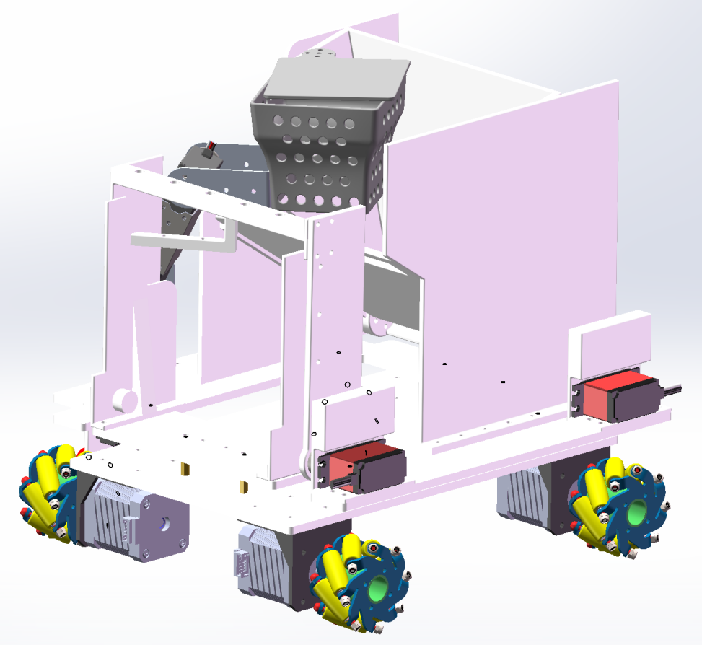

6.1 The Manipulation Module

6.1.1 The Picking Mechanism
The egg picking mechanism consists of three main components: a robotic arm, a collection bin, and a scraper at the end-effector, which is equipped with a pressure sensor. This design integrates egg picking and classification into a single process.
The robot features a three-degree-of-freedom articulated robotic arm, constructed from three serially connected servos. It enables millimeter-level precise positioning in the vertical plane and flexible rotation in the horizontal plane. This configuration allows the robot to accurately deposit good and bad eggs into separate storage bins without moving the chassis, significantly simplifying the collection process. It serves as the core execution unit of the automated egg collection system.
The egg collection bin adopts a unique trapezoidal structure, wider at the bottom and narrower at the top. This design expands the effective collection range while ensuring that eggs are centered over the pressure sensor for more accurate detection. Additionally, the larger bottom area lowers the center of gravity and enhances structural stability.
The bin walls feature a honeycomb-patterned perforated design, reinforced with interstitial ribs to form micro-scale rib plates. This not only reduces structural weight but also maintains adequate stiffness and strength, achieving an efficient balance between lightness and load-bearing capability.
The scraper edge includes limit ridges to ensure full contact between the egg and the pressure sensor at the scraper’s center. The pressure sensor monitors contact force in real-time and, through a preset threshold, accurately distinguishes between good and bad eggs. The result is a highly precise sorting mechanism.
Figure 6-2 The Picking Mechanism
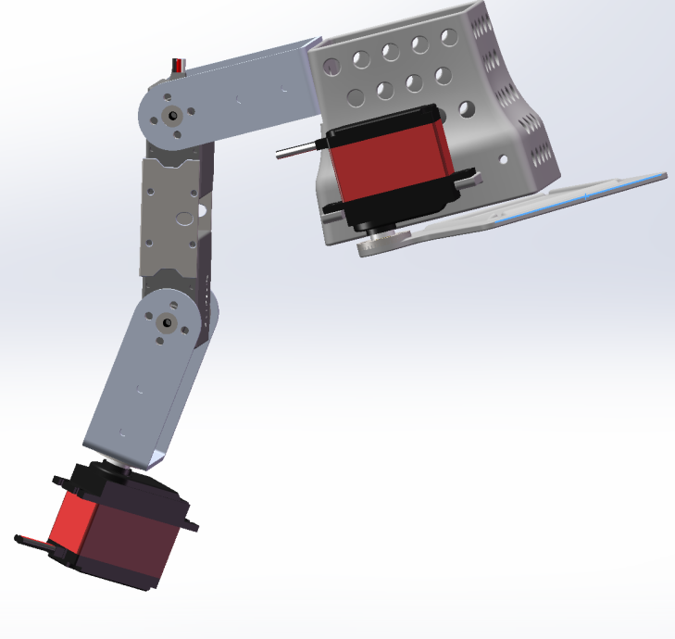

6.1.2 The Storage Mechanism
The storage mechanism is divided into two compartments: one for solid eggs and another for bad eggs, both designed to store all collected eggs during the competition task. The release of both solid and bad eggs into their respective egg bins occurs only once per run.
The solid egg storage consists of a container with an inclined surface lined with a 5 mm thick foam layer, ensuring that the drop of Large Magnetic Eggs does not result in cracking or breakage. Since the number of solid eggs to be stored is significantly higher than that of bad eggs, the solid egg storage compartment occupies the majority of the upper-level space.
In contrast, the bad egg storage area is designed as a flexible space, made of fabric connected to the bad egg frame and an opening-and-closing linkage. This configuration sufficiently accommodates the storage needs of bad eggs while optimizing space usage.

6.1.3 The Release Mechanism
The release mechanism is divided into two parts: one for solid eggs and another for bad eggs, both designed to guide eggs as they roll into their designated egg bins.
The solid egg release mechanism is connected to two side-mounted servos. By rotating around a fixed axis, it controls the movement of a hinged release panel, allowing solid eggs to roll down the panel into the designated egg bin. Side walls of appropriate height are installed on both sides of the panel to prevent solid eggs from rolling out of bounds during the release process.
The bad egg release mechanism is integrated with its storage mechanism. During the collection phase, it functions as the storage container for bad eggs. In the final release phase, a servo rotates to tighten the previously slack fabric, bringing it into contact with the base. This forms a ramp that allows the bad eggs to roll down along the fabric into the designated egg bin. Similarly, side walls of suitable height are also installed on both sides of the bad egg frame to prevent eggs from rolling outside the target area during discharge.
Figure 6-3 The Storage and Release Mechanism
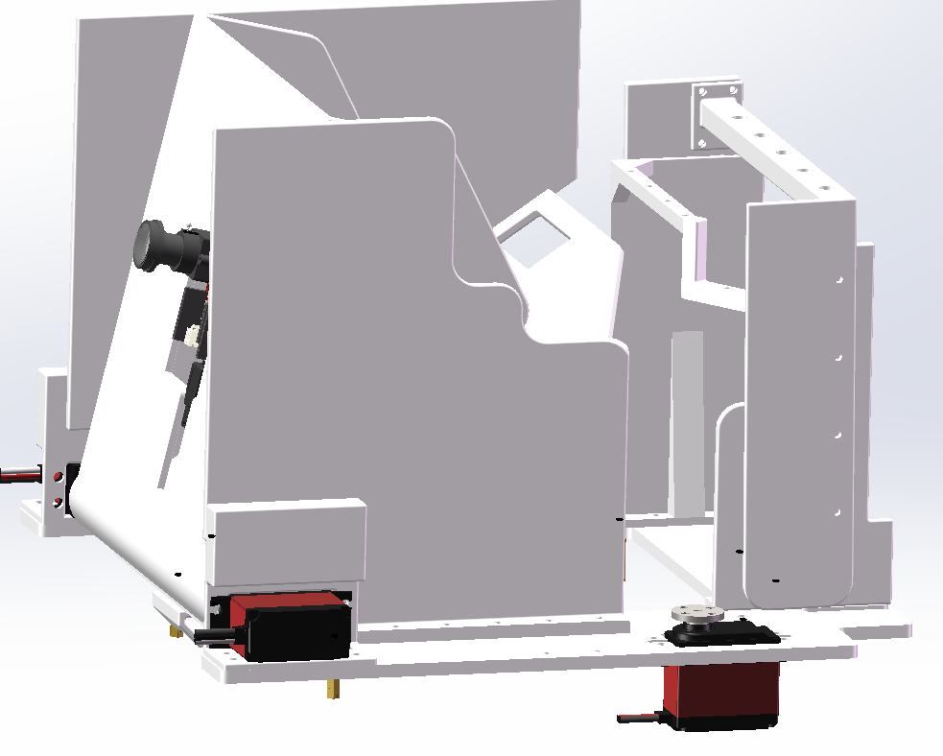

6.2 The Mobility Module
The chassis adopts a Mecanum wheel and stepper motor system as its mobility unit, enabling free movement in a two-dimensional plane. Mecanum wheels are composed of multiple rollers arranged in a radial configuration, and through spatial vector decomposition, the tangential forces generated by the wheel rotation are converted into a resultant force for system propulsion. With appropriate theoretical calculations, the speed and rotation direction of each wheel can be controlled to synthesize a planar motion vector in any desired direction, achieving precise omnidirectional mobility.
The stepper motors employ pulse-width modulation (PWM) microstepping control technology, allowing for accurate open-loop adjustment of angular displacement. This motor model features low thermal loss, fast dynamic response, and high positional accuracy, providing a solid foundation for precise power output in the omnidirectional mobility system.
Figure 6-4 The Mobility Chassis
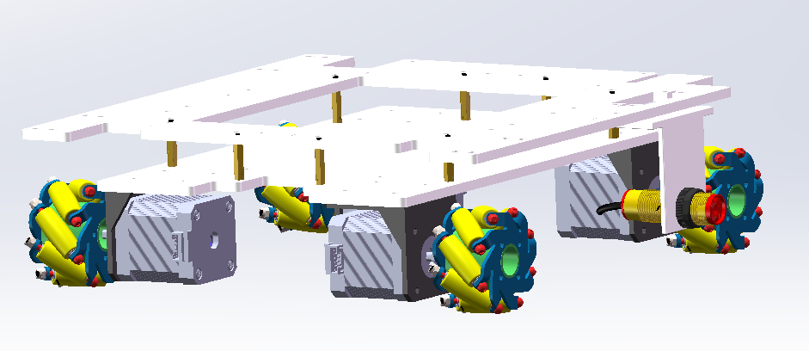

6.3 The Control Module

6.3.1Arduino Mega 2560 Pro
Our robot uses the Arduino Mega 2560 Pro as its main controller. The microprocessor is built around the ATmega2560 processor and features a total of 54 digital I/O pins (numbered 0–53), 16 analog input pins (A0–A15), 6 external interrupt pins (INT0–INT5), and 6 timers (TIM0–TIM5). The Arduino Mega 2560 Pro operates at a 16 MHz clock frequency, which serves as its main clock source.
The Arduino Mega 2560 Pro is responsible for processing data received from various sensors, as well as executing control over the four stepper motors on the chassis, the robotic arm, and multiple servo motors.

Figure 6-5 Arduino Mega 2560
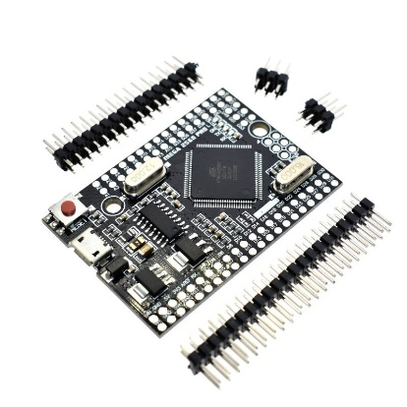

6.3.2 Laser Based Photoelectric Sensor
The laser based photoelectric sensor is a device that uses infrared laser as the detection light source, primarily composed of a transmitter and a receiver. The transmitter contains an infrared laser diode capable of emitting a focused infrared laser beam, while the receiver is equipped with a photodiode or phototransistor to receive and convert the infrared laser signal.
When an object blocks or reflects the laser beam, the signal received by the receiver changes, allowing the system to determine the presence or movement of the object. This type of sensor is known for its high precision, strong stability, and robust anti-interference capability. Infrared lasers offer higher brightness and directionality, enabling reliable long-distance detection and making them less susceptible to ambient light interference.
In the project, the sensor is primarily used for measuring the distance to the egg, ensuring that the robot maintains an appropriate position for the robotic arm to accurately collect the egg.
Figure 6-6 Laser Based Photoelectric Sensor
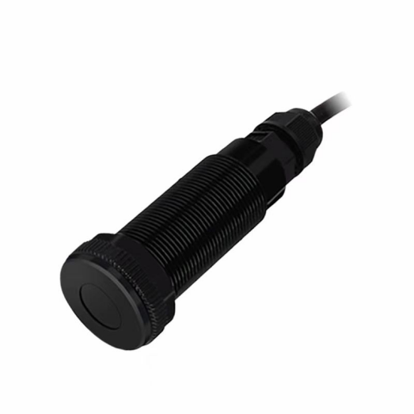

6.3.3 Thin Film Pressure Sensor
This robot employs the FSR406 resistive thin-film pressure sensor (model RP-S40-ST), which features a square short-tail package with overall dimensions of 40 × 40 mm and a height of 55 mm. It offers an effective sensing area of 36.5 mm², and utilizes the nonlinear resistance-force characteristics of a pressure-sensitive semiconductor layer to achieve wide-range force detection from 20 grams to 10 kilograms—where the resistance decreases significantly as the applied force increases, and approaches infinity under no load.
The sensor is equipped with 5 mm long pins at a standard 2.54 mm pitch, allowing for quick integration into PCBs. Thanks to its fast dynamic response, this sensor serves as a key component for assessing egg quality during the collection process.
Figure 6-7 Thin Film Pressure Sensor Module

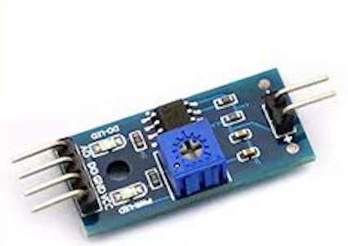

6.3.4 Camera
The robot uses the OpenMV N6 as its camera module. This module is an open-source, low-power, and embedded machine vision platform, which simplifies the implementation of complex vision algorithms through a MicroPython programming interface.
Its core processor is the STM32H743II ARM Cortex-M7, and it is equipped with an OV7725 image sensor, supporting 320×240 RGB565 color images and 640×480 grayscale images. The lens uses a standard M12 mount, with a 2.8 mm focal length and a 115° field of view.
In this robot, the OpenMV N6—combined with the Canny edge detection algorithm—is used to locate the tracking line and enable full-field navigation.
Figure 6-8 OpenMV Cam
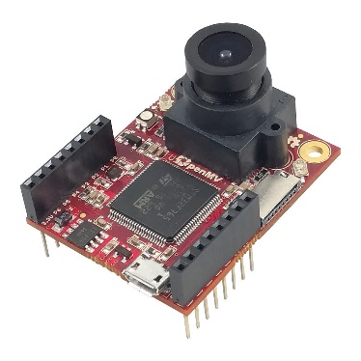

6.3.5 Printed Circuit Board
We have developed a custom-designed printed circuit board (PCB) capable of connecting the microprocessor with various electronic components. This PCB is highly versatile and equipped with multiple interfaces, making it well-suited for a wide range of robotic applications.
The PCB integrates several modules, including a laser sensor module, pressure sensor module, vision module, motor control module, power supply, and serial communication interface. It serves as the central platform for data acquisition and command transmission across the system.
To power the Arduino and other external sensors, we incorporated a 5V voltage regulator module onto the PCB. In addition, two adjustable DC voltage regulator modules are provided. The voltage from the lithium battery is routed through terminal blocks on the PCB to the regulators, where it is stepped down to 6V and 12V respectively—supplying power to the servo motors and stepper motors, and ensuring they receive the necessary electrical input for stable operation.
Figure 6-9 PCB circuit board
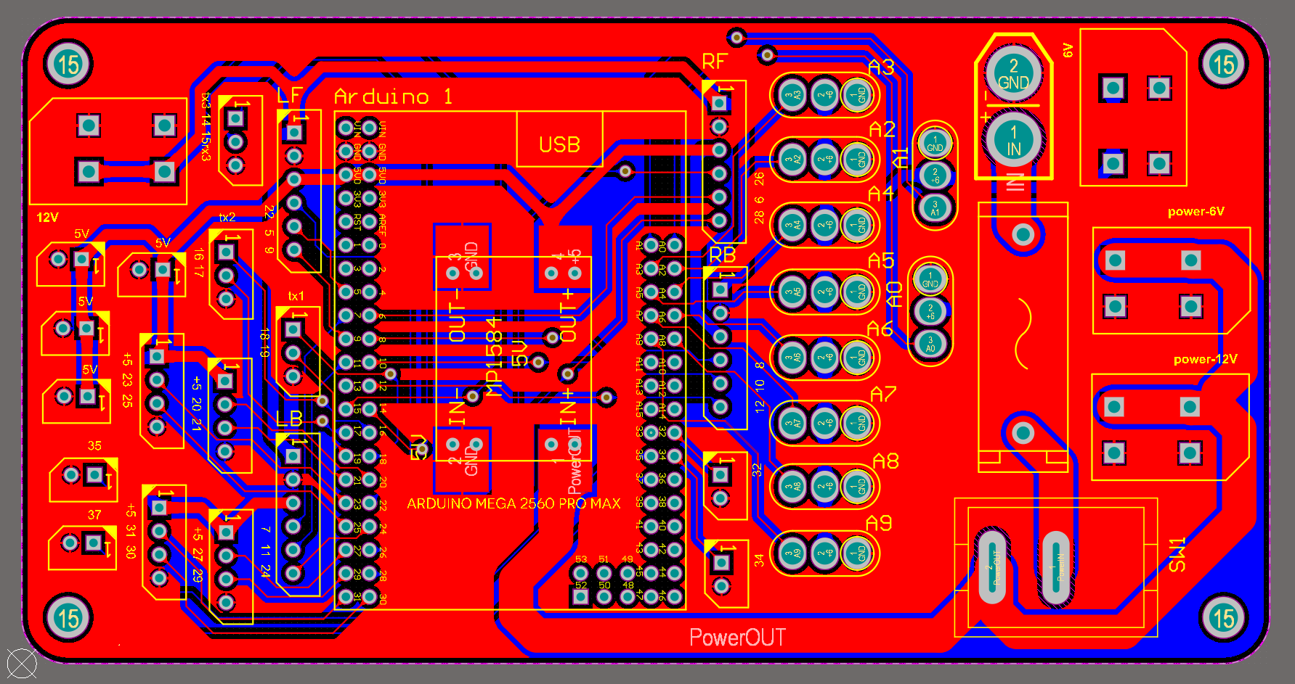

7 Software Overview

7.1 Overall Software Workflow
Figure 7-1 Overall Software Workflow
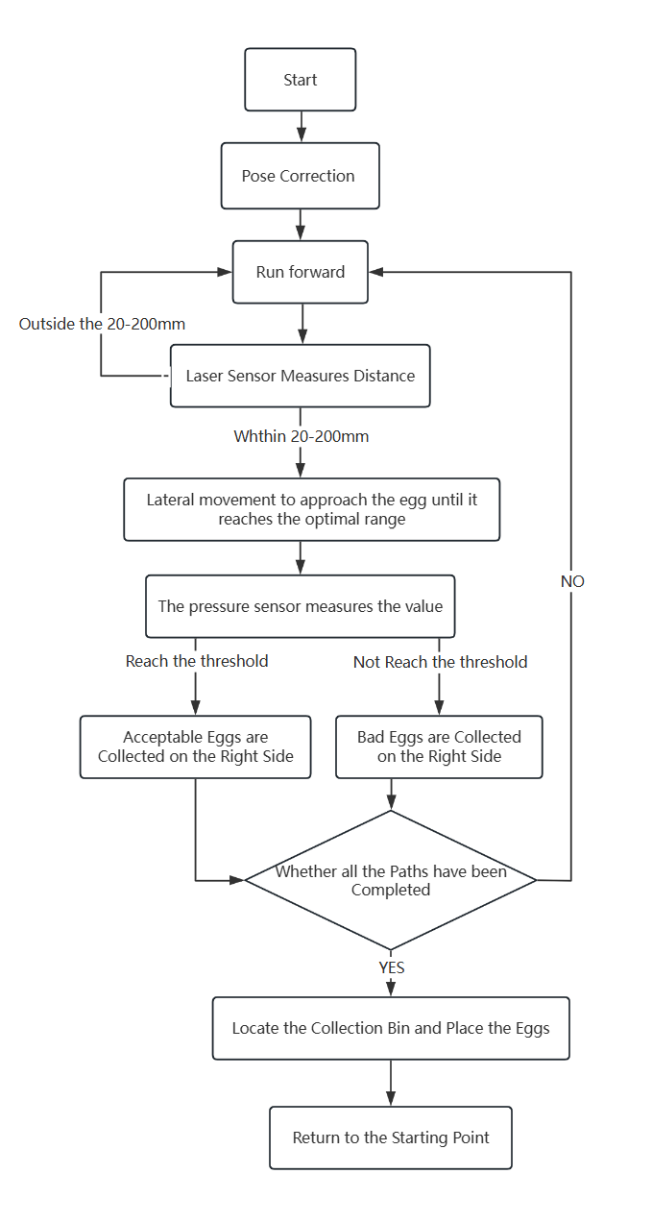
The software workflow is illustrated in the diagram. Overall, it consists of the visual navigation module code and the egg detection and collection module code.
After the robot starts up, it uses the visual module to detect the tracking line and perform posture correction, enabling it to move straight along the line. While the robot moves forward, the laser rangefinder module on the left continuously detects whether any egg enters the range of 20–200 mm. When an egg is detected within this range, the robot stops advancing and adjusts its lateral position according to the distance value returned by the laser rangefinder, until it reaches the optimal distance range. Then, the robotic arm is lowered to collect the egg into the container at the end of the arm.
Inside the container, the egg’s weight is measured by a thin-film pressure sensor. For a good egg, the pressure value exceeds the sensor threshold, and the robot identifies it as a good egg, lighting a green light. For a bad egg, the pressure value is below the threshold, and the robot identifies it as a bad egg, lighting a red light. After classification, the robotic arm is raised, and depending on the classification result, the egg is deposited into either the good-egg bin or the bad-egg bin.
The robot continues repeatedly — moving forward, detecting eggs, adjusting laterally, collecting and classifying — until the visual module detects that the robot has reached the end of a row. At that point, the robot retracts its arm, turns or makes a U-turn, and enters the next row to perform the same operations. This continues until the robot determines that it has finished all the rows.
After completing all rows, the robot, guided by the visual module, moves to the egg bin and unloads the good and bad eggs from their respective containers. It then automatically returns to the starting area and shuts down, completing all assigned tasks.

7.2 Visual Navigation Module
The robot’ s visual navigation module primarily utilizes OpenMV as the vision sensor and processor. It communicates with the Arduino Mega 2560 Pro via UART serial interface to transmit processed visual data. This information is ultimately used to control the rotation of the four motors on the chassis, accomplishing the navigation task — primarily the heading angle correction mechanism.
OpenMV captures images of the ground in front of the robot. The images are converted to grayscale, and a region of interest (ROI) and mask are created to segment the competition field, focusing only on the area directly in front of the robot. The Canny edge detection algorithm is used to segment the tracking line from the rest of the field. Each segmented tracking line is treated as a rectangle, and the centroid of each rectangle is located. The x-axis deviation between each centroid and the center line of the field of view is calculated to determine the offset distances.
These offset distances are then weighted with gradually increasing values from far to near, summed up to obtain a computed offset value for the robot. This value is transmitted to the Arduino Mega 2560 Pro via the UART serial interface as a reference for heading angle correction. Based on the calculated offset, the Arduino Mega 2560 Pro determines the desired rotational speeds of the four wheels and sends control signals to the four stepper motors on the chassis, thereby correcting the robot's heading angle.
Figure 7-2 Grayscale Image from the Camera
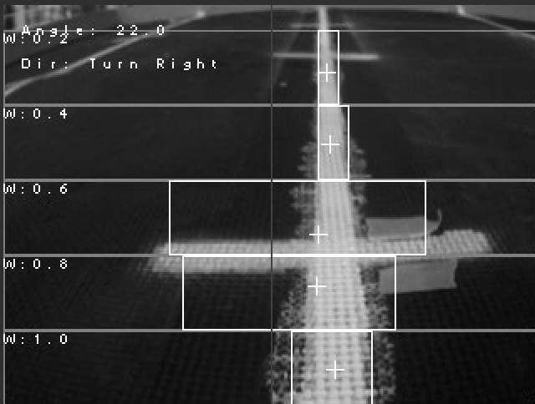

7.3 Egg Detection and Collection Module
The egg positioning and collection module uses a laser rangefinder as its sensor to acquire the lateral distance between the robot and the egg. This distance information is transmitted via the UART serial interface to the Arduino Mega 2560 Pro, which ultimately controls the robot's lateral movement until the egg enters the designated collection range. Once within range, the robotic arm performs the collection.
Figure 7-3 Laser Sensors Collect Data
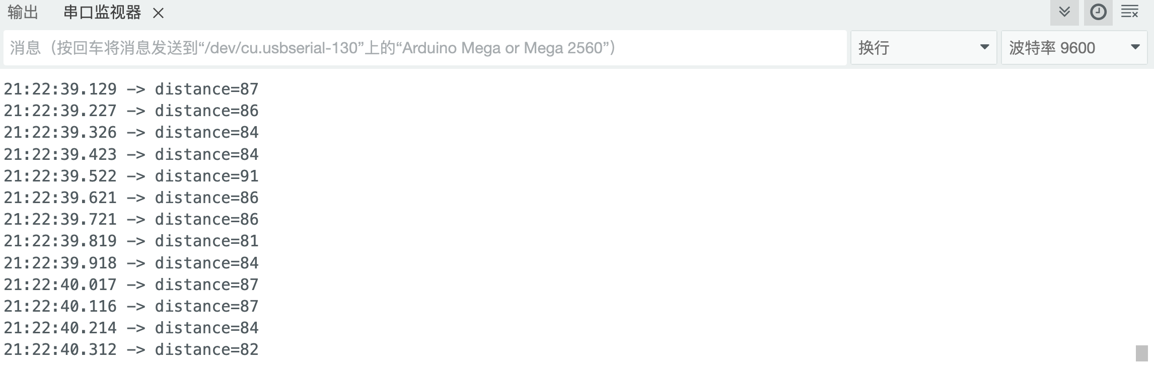
The laser sensor, based on Time-of-Flight (ToF) technology, measures the lateral distance between the robot and the egg. Its built-in chip automatically calculates the distance, and the result is sent to the Arduino Mega 2560 Pro. Based on the received distance, the Arduino uses a Proportional-Derivative (PD) algorithm to compute the rotational speeds of the four chassis wheels, enabling smooth lateral movement of the robot as it gradually approaches the egg. This process continues until the measured distance falls within the target range.
The PD algorithm takes the current distance as input and outputs the motor speed, with the feedback value being the adjusted distance after motion. Once within the desired range, the robotic arm lowers to a joint angle, allowing the end-effector container to fully cover the egg. Simultaneously, the bottom scraper retracts, guiding the egg into the container.
A thin-film pressure sensor located on the bottom plate converts the pressure signal into a continuous pressure value through linear transformation. If the measured pressure exceeds a predefined threshold, the egg is classified as a good egg; otherwise, it is considered a bad egg. The indicator light turns green for a good egg and red for a bad egg.
Following classification, the robotic arm lifts, and the lower joint rotates in the plane of the chassis. Depending on the classification result, it rotates to align the end container with the correct bin, and the egg is deposited into the appropriate bin, completing the classification and collection process.

8 Achievement of the Objectives
We have successfully achieved all the goals and design standards required for the competition. Robots have demonstrated excellent capabilities in navigation, egg identification, egg handling and egg collection and sorting. Our robot effectively distinguishes between large solid eggs and medium bad eggs, and can accurately collect and store them separately without interfering with each other. The design of the robot remains within the required size of 12 "x 12" x 12 ", and can perfectly meet our requirements without human intervention or wireless communication. In addition, we also considered the problem of fragile eggs in reality, and added many foam pads in the layout of the robot to reduce collisions. We have comprehensively considered speed, accuracy, and efficiency in navigation and egg collection and classification to help us better cope with competition venues and real-life livestock farms, meeting all project goals successfully.

9 References
- Dazhang, Y., Hengyi, Z. & Luwen, S. 2024, "Robotic Arm Motion Planning Based on an Improved PRM Robotic Arm Motion Planning Based on an Improved PRM", Jixie Chuandong, vol. 48, pp. 87-93.
- Yao, C. 2021, "Floating Garbage Collector Based on OpenMV", Journal of physics. Conference series, vol. 1952, no. 3, pp. 32058.
- Guo, Y., Yin, J., Wang, Y., Wu, S., Luo, L. & Fu, Q. 2022, "Research and Implementation of an OpenMV-Based Target Edge Detection and Tracking System", Journal of physics. Conference series, vol. 2173, no. 1, pp. 12083.
- Shafiq, M.U., Imran, A., Maznoor, S., Majeed, A.H., Ahmed, B., Khan, I. & Mohamed, A. 2024, "Real-time navigation of mecanum wheel-based mobile robot in a dynamic environment Real-time navigation of mecanum wheel-based mobile robot in a dynamic environment", Heliyon, vol. 10, no. 5, pp. e26829.
- Vroegindeweij, B.A., van Willigenburg, G.L., Groot Koerkamp, P.W.G. & van Henten, E.J. 2014, "Path planning for the autonomous collection of eggs on floors", Biosystems engineering, vol. 121, pp. 186-199.
- Dunbar, N. 2020, Arduino software internals: a complete guide to how your Arduino language and hardware work together, 1;1st; edn, Apress L. P, Berkeley, CA.
- Format preview Bräunl, T. 2022, Embedded robotics: from mobile robots to autonomous vehicles with Raspberry Pi and Arduino, Fourth edn, Springer Singapore, Singapore.

